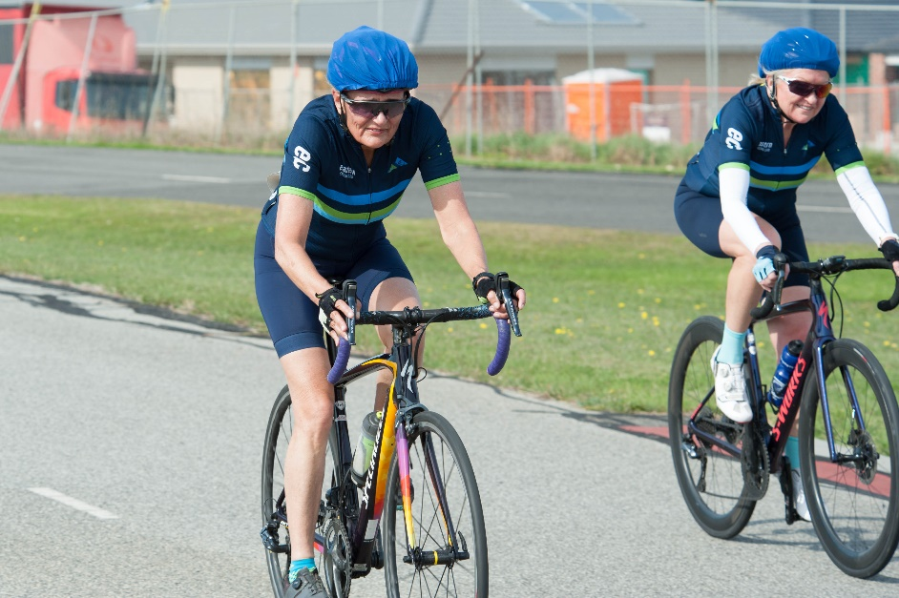
Members Handbook

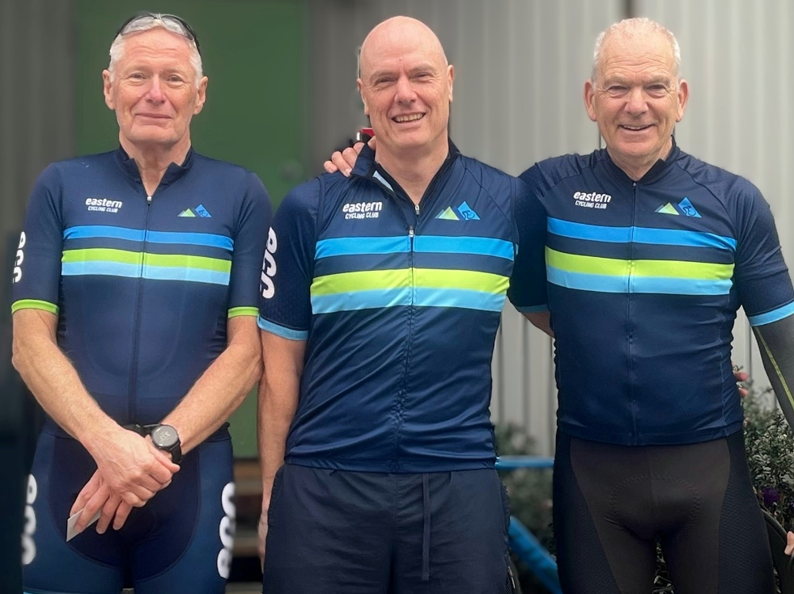

Contents
1. About Us 3
2. Club Board 4
3. Membership & Fees 5
4. Racing 5
5. Race Day Roster 11
6. Newsletter 13
7. Club Clothing 13
8. Racing Etiquette 14
9. The Secret of Handicap Racing 15

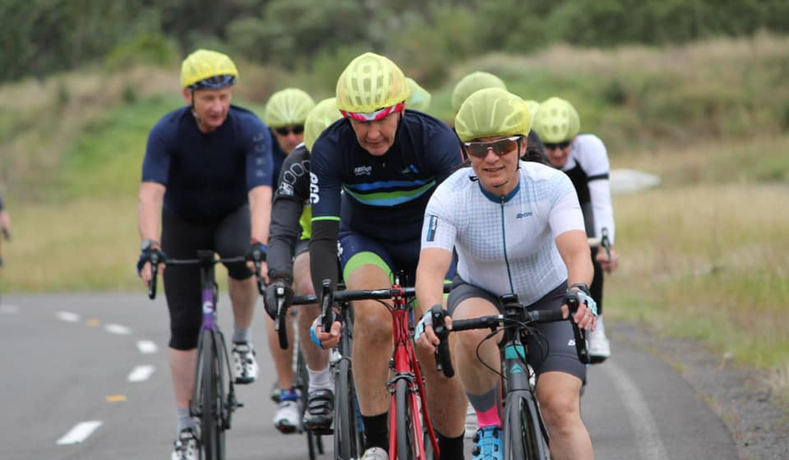

About Us
Eastern Cycling Club (ECC) strives to be a diverse and friendly club providing a safe and inclusive environment with competitive Road Racing for Males and Females over 30.
We are about safety, fitness, competitive & fun racing. Cyclists become eligible for racing in the year that they turn 30 for females and males (Masters). Eastern Cycling Club is a member of AusCycling.
The club runs approximately 130 races per year over two seasons: Summer – criteriums, and Winter – road races. Most races are graded scratch races (A to F) where competitors compete against riders of similar strength and ability. Races are conducted at both closed and open road circuits. With the exception of Club Championships, and the Tour de Metro (Eastern v Northern), all races are open to all AusCycling licensed riders.
The club currently boasts around 181 members and is always looking for new members of any cycling standard.
ECC is a road racing club based around the eastern suburbs of Melbourne. Club races are held:
- Tuesday evenings (only in daylight saving months) at METEC. Racing commences at 6.00pm
- Wednesday mornings at The Teardrop, Yarra Blvd. Racing commences at 10:00am
- Saturday afternoons or Sunday morning at various locations. Please make sure you check the ﬁxture for start time.

Most races are graded according to ability and are conducted in a friendly and supportive atmosphere. The club is well known as the friendliest cycle racing club in Victoria and provides a great opportunity to learn about racing, to enjoy the company of other cyclists and improve ﬁtness. The prime functions of the club are to:
- Organise and conduct races for Masters in a safe environment.
- Provide a friendly relaxed atmosphere for members to get to know each other.
- Educate members regarding the rules and club racing etiquette and to ensure that these rules and the club racing etiquette are adhered to.
- Provide racing and training tips for members.

easterncycling.com

Club Board
The Eastern Cycling Club is managed and organised by an elected Board and appointed by its members at the Annual General Meeting. Members are encouraged to participate on the Board and to attend General Meetings. A club (ﬁnancial) member may nominate for the Board. Nominations must be on an ofﬁcial nomination form (available from the club website). A member must be nominated by two club members. The attendees at the AGM will then vote for the nominations and elect a new Board for the year. Each year a list of the elected and appointed Board members and their contact details will be sent to members after the AGM has been held. board@easterncycling.com
The following is a list of positions elected or appointed each year:

BOARD POSITIONS (8)
- President
- Secretary
- Treasurer
- Handicapper
- Club Captain
- 3 x Board Member with position

It is important to note that there are other roles in the club that are performed
by members as follows:

  - Roster Coordinator
  - Permit Coordinator
  - Newsletter Editor
  - Assistant Handicapper
  - Race Committee

Club meetings are held at 7.00pm on the second Wednesday of the month. Club meetings are conducted in person or virtually. Members are most welcome to attend and should contact the secretary for the Agenda and details of the location. secretary@easterncycling.com
The Annual General Meeting is held in March on the same night as the monthly club meeting. Again, members are encouraged to attend.

Membership & Fees
To compete in races, riders need an AusCycling membership. AusCycling memberships are valid for a 12-month period and can be purchased at any time during the year. You can choose to pay for a full annual membership or opt for a 12-month payment plan which will renew automatically until you cancel, which you can do at any time. www.auscycling.org.au/membership/race-all-discipline
Membership fees are payable each year and include ﬁrst aid costs for racing, insurance and AusCycling membership fee. Members will be sent a reminder to renew their membership from AusCycling which they will need to do online through the AusCycling website. If you require any assistance or advice about memberships, please contact the Secretary.

Race entry fees are dependent on the specific event – contactless race entry is done via entryboss.cc. To use this online entry system, create an account. The details of the event and the cost shall be displayed in www.entryboss.cc

Wednesday racing at the Teardrop is only paid in cash ($5) on the day or by paying 6 months prepaid via entryboss.cc

Racing
Racing Type
Each year ECC organizes a summer race program and a winter race program. Calendars of the race programs are made available to members on the website and entryboss.cc.
Races in the summer season are generally of a Criterium format - races of approximately an hour (A grade) duration around a 1-2km circuit. The winter season mainly comprises road races on open roads covering distances from 32 to 70 kilometres depending on the grade and format.
The formats of races run by the club are:
Scratch Race - A Scratch Race is a race where riders are separated into bunches (A - F) based on ability and riders race against each other within their allocated bunch.
Handicap Race - A Handicap Race is a race where all riders compete against each other in a single race. Riders of similar ability are grouped together – generally by grade or if numbers allow multiple groups per grade. The lower grade riders start ﬁrst and this group is known as “limit”.
The handicapper will determine a time gap between each subsequent group and as this time is reached riders of increasing strength will start their race. The last and strongest group to start are known as “scratch”.
Time Trials - The club runs two -time trials each year; a ﬂat time trial (the Robert Graham Memorial TT) and a team TT. These are individual races against the clock but handicapped such that all members, regardless of strength, have the chance of winning.
Club Championships - Where riders race against each other according to age. These are run in 5-year age groups which is the standard adopted throughout AusCycling Masters racing. To qualify for Club Championships, riders must have ridden three or more races during the season.
Racing Safety
ECC obtains police, local government and Vic Roads permission to hold all events. It also provides trafﬁc controllers, race marshals, corner stewards, safety and advisory signage, radios, a comprehensive ﬁrst aid kit and qualiﬁed ﬁrst aider. Lead and follow cars are also provided for all road races.
Handicapping
ECC operates a handicapping system based on records of previous results to determine which grade a rider will race. The intention of handicapping is to allow all riders the opportunity to compete in a race which suits their experience, ability and normal ﬁtness level, while maintaining the safety of all competitors.
Consistently placing (1st to 3rd) will result in the Handicapper recommending to the rider that they should try a higher grade. Conversely, where the Handicapper sees a rider being dropped regularly, the Handicapper may suggest to a rider that they may be better racing in a lower grade.
In the event a rider hasn’t been to any races for a few weeks or months (holidays, work, sick, injury, etc), they may either race in the grade they last raced or one grade lower subject to the Handicappers approval.
A rider who believes they are no longer competitive in their current grade, and wish to be considered for promotion/demotion, can discuss their concerns with the Handicapper, outlining their case a couple of days ahead of the next race, not on race day. handicapper@easterncycling.com

In general, riders are not permitted to temporarily drop a grade because of brief interruptions to training levels, colds, because ‘my coach said I should have an easy week’ etc. Grade changes are based on results at ECC events. While consideration may be given to places at other club’s events, it is your ability to handle the racing at ECC that is of primary importance.

Grades
A Grade (White) – average speeds generally above 38kmh
Suits – strong and very experienced riders. Excellent cornering and bunch riding skills are required. At least one win and several other placings at B Grade level is a prerequisite for acceptance into an ECC A Grade ﬁeld.
B Grade (Green) – average speeds are generally around 34 – 38kmh
Suits – strong and experienced riders. B Grade riders have generally accumulated consistent top four places in C grade competition and should have very good bunch riding skills and understanding of race tactics and etiquette.
C Grade (Blue) – average speed 31 – 35kmh
Suits – riders with bunch riding experience. C Grade ﬁelds often comprise a mix of experienced racers, newer riders, and riders who have moved up from D Grade after achieving consistent places over time, as well as riders who have too much strength for the D Grade race to provide them with meaningful competition. Strong riders will often move very quickly into B Grade.
D Grade (Yellow) – average speed 28 – 32kmh
Suits – experienced riders who do not have the strength or ﬁtness to compete in a higher grade, and new or younger competitors aiming to build experience and strength.
E Grade (Red) – average speed 25 - 29kmh
Suits – experienced riders who do not have the strength or ﬁtness to compete in a higher grade, and new or younger competitors aiming to build experience and strength.
F Grade (Purple) – average speed less than 25kmh
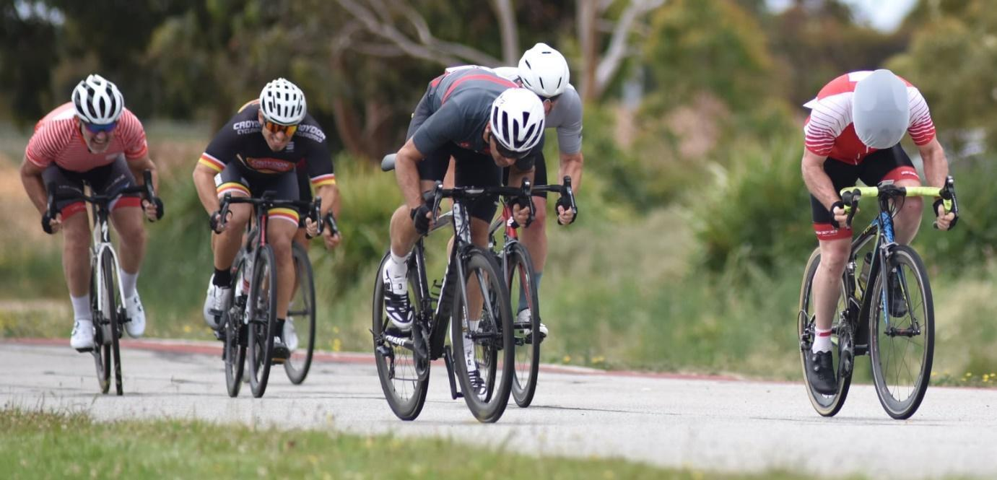
Suits – experienced riders who do not have the strength or ﬁtness to compete in a higher grade, and new or younger competitors aiming to build experience and strength.
Circuits
Circuit | Address | Description | Course Type
METEC | Colchester Rd, Kilsyth | Metropolitan Trafﬁc Education Centre – 1.21 km circuit  METEC is a trafﬁc free Criterium circuit used regularly by ECC. Surface is relatively rough. | Loop Flat
Dunlop Road | Dunlop Road, Mulgrave | Criterium circuit on public road – 1.40 km Parking available in Dunlop Rd and Geddes St. | Loop, Flat
Casey Fields | Casey Fields Criterium Circuit, Cranbourne East | Dedicated 2.25km Criterium circuit. Excellent surface, fast sweeping corners. | Loop, Flat
The Teardrop | Yarra Boulevard, Kew | Racing is anticlockwise on a closed road circuit of 1km with an excellent surface and a  200 m long climb. | Loop, Hilly
Bazalgette Crescent | Bazalgette Crescent, Dandenong South | Open road circuit that is used for the Club Criterium Championships. Excellent surface. 1.59km | Loop, Flat
Rocco Drive | Rocco Drive, Scoresby | Open road circuit. Good surface. 0.99km. | Loop, Hilly
Yarra Glen | Glenview Road, Yarra Glen | A 4.52 km circuit starting across from Yarra Glen Cemetery on Glenview Road. Race distances vary from 6 to 12 laps depending upon grade.  Park near Yarra Glen cemetery. | Loop, Hilly
Gruyere | Killara Road, Gruyere | A 5.16 km circuit starting at the Gruyere Recreation Reserve. Race distances vary from 6 to 12 laps depending upon grade. | Loop, Hilly

Circuit | Address | Description | Course Type
Holloway Drive | Holloway Drive, Bayswater | Open road circuit. Excellent surface. 1.44km | Loop, Flat
Seymour |  | This is our handicap course, a relatively ﬂat parcour of two 26km out-and-back laps Registrations are in Manners St, Seymour, across the road from the Royal Hotel.  Note: that registration is nearly six kilometres from the race start, you will need to allow sufﬁcient time to get from one to the other. Post-race presentations are held in the Royal Hotel. | Out & Back, Flat
Jindivick | Kydd-Parke Reserve, Jackson Track, Jindivick | Challenging 19.62 km circuit not for the faint hearted.  Race distances vary from 1 to 3 laps depending upon grade. | Loop, Hilly
Thornton | Riverside Drive, Eildon | Course consists of a 25 km loop around the Eildon Pond. Used for Individual time trial (1 lap), Team time trial (2 laps) or GSR/handicaps (2-3 laps) | Loop, Flat
Broadford Motorcycle Complex | 260 Strath Creek Road, Broadford Victoria 3658 | Challenging 2.3 km circuit not for the faint hearted. | Loop, Hilly
Note regarding out and back courses
To avoid lead riders of a bunch gaining an unfair advantage on the turns of out and back courses, the turns at either end of the circuit are neutral for at least 100m either side of the turn. The front riders must slow down to wait for those at the back of the bunch to make the turn and regain the bunch. Failure to wait could result in disqualiﬁcation. This does not apply to a rider or riders who have a clear lead over the bunch.
Race Day Information
The event details can be found on Entryboss.cc including the start time, address, and race type.
Riders will be issued a number to pin on the rear of their jersey and a helmet cover to distinguish their particular grade. Each rider is responsible for the return of these items at the end of the race and may be required to pay a penalty if they are not returned.
In the road races (open roads) competitors are recommended to:
- Carry the necessary spares and equipment to ﬁx a puncture.
- It is recommended that your bike is ﬁtted with a front and rear light while on open road racing, however lights are at the rider’s discretion.
- It is also advisable to avoid wearing dark clothing for road races.
In Criteriums all attachments (pumps, under-saddle bags, lights, cameras, etc.) are to be removed from the bike.
New members will be assisted by the club captain or other experienced riders if they are new to racing. Riders should attend the presentation ceremony which is held approximately 30 minutes after the ﬁnish of the last race.
Rules
As well as abiding by the rules as set out by AusCycling, members are also required to follow these basic ECC rules. Bunch Captains (usually very experienced club members) will be nominated for each grade with more than 10 riders to ensure that riders comply with the rules.
- Road racing bikes with drop handlebars are used for all races conducted by ECC. Bikes with ﬁxed gears and/or eBikes are not permitted.
- It is mandatory that all state trafﬁc laws / road rules are observed. Riders found to be breaking trafﬁc laws / road rules or cutting corners on clockwise courses will be disqualified from the race and may face suspension.
  - Passing of higher grades is not permitted unless otherwise speciﬁed at the start of a race.
  - The use of a higher grade to gain advantage either by drafting or using it to jump away from your bunch is not permitted. Riders who have gained an advantage will be disqualified.
  - Passing on the inside of a corner is not permitted.
  - When passing a lower grade do not cut down when completing the pass.
  - Do not verbally or physically abuse or intimidate fellow riders.
  - Bicycles must be appropriate for road racing and in a sound mechanical condition.
  - Follow any instructions or rules from club ofﬁcials, race ofﬁcials or bunch captains on the day that may be necessitated by circumstances on the day i.e., a particular course, the number of riders racing, the weather conditions and any other circumstances that may affect rider safety.
  - Riders must use the toilets available at the race venues. Failure to do so will incur penalties including ﬁnes and/or suspension.
  - Criterium Races only – If a rider has a mechanical issue with their bike, the rider shall have a minimum of 1 lap as per AusCycling Technical Regulations 2.03 Criterium and re-join the race in the same position prior to the mechanical issue.
Ambulance Policy
It is Club policy that in the event of a fall where a rider or riders are injured, the Race Controller in consultation with the First Aid Officer will make a judgement call on whether an ambulance should be called. Although the injured rider(s) will be consulted on whether an ambulance is required, the ﬁnal decision will be left in the hands of the club ofﬁcials. The club has been provided with guidelines by qualiﬁed paramedics to make this decision when necessary.
If a rider is not an Ambulance Victoria Member, they will be liable for the costs of the call out.
Members are strongly advised to make sure they are members of the ambulance service. For more information about an ambulance subscription please go to www.ambulance.vic.gov.au.
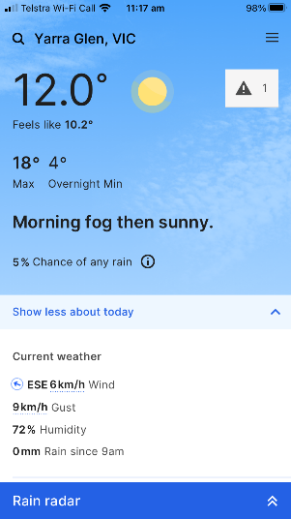
Weather Policy
Racing may be cancelled due to weather and club ofﬁcials may make a decision to do this if the conditions make it unsafe for racing i.e. if the road or course is too wet or if it is too hot. ECC follows the AusCycling Extreme Weather Policy – link here. A decision will be made at the earliest possible opportunity and communicated by email, SMS, Facebook and entryboss.cc
This policy applies to all racing.

Race Day Roster
Each club member of ECC is required to perform race ofﬁcials’ duties. As with most cycling clubs ECC has a roster system to run racing safely and efﬁciently. Members are usually rostered at least once per season. Rosters are made available before the start of the season and can be found on the club website at easterncycling.com. This allows plenty of advance notice for members to put their duty date in the diaries or arrange swaps! It is a small expectation on each member and ensures that all members are given an equal chance to race over the year. Not turning up for duty means that someone else will have to forgo racing to ﬁll your spot.
Members who fail to do their rostered turn of duty will be suspended from racing until they have completed their duty commitments.
If you are unable to attend, or would like to race, on your rostered day, it is your responsibility to organise a replacement or swap with another member to a mutually agreed date. All swaps must be notiﬁed to the ECC Roster coordinator. roster@easterncycling.com
Rostered members are requested to conﬁrm their availability by the Wednesday prior to race day with the Roster coordinator. If you cannot ﬁnd a replacement after exhausting all possibilities, you must notify the Roster coordinator ASAP and at least by the Wednesday prior to racing; NOT THE MORNING OF THE RACE!
On the day of your duty please be at the race circuit at least 1 hour before the scheduled race start time. Please ensure that you familiarise yourself with your roles and responsibilities from notes in the Race Controller Kit on the website or available in the trailer at the race. You will be given your instructions by the Race Controller which may include one or more of the following tasks:
- Set up and remove signage before and after the race.
- Take entries.
- Assist with entry money.
- Assist with race numbers.
- Drive lead or follow car.
- Corner marshal.
- Assist at Start/Finish.
- Assist with presentation and the setting up of the podiums.
Race Cancellation Duty Impact
The following documents the policy for ECC roster duty in the event a race is cancelled due to any reason (E.g. Weather, restrictions, lockdown, etc.):
a. If a race is cancelled by the race committee, Referee or by government restrictions 24 hours or less prior to the scheduled race time, it will be considered that the people on roster duty have completed their duty requirement.
b. If a race is cancelled by the race committee, Referee or by government restrictions more than 24 hours prior to the scheduled race time, it will be considered that the people on roster have not completed their duty requirement. In this case the roster coordinator shall roster these people to the next event that has duty openings or to the top of the list for the next roster schedule.
Add on Member – Duty Roster
Add-on Members of Eastern Cycling Club who race regularly, 10 or more races (Tuesday, Wednesday or Weekend) in a calendar year, are expected to perform duty of a minimum of 1 in a calendar year.

Newsletter
The club publishes a weekly newsletter that includes race reports and other relevant information. Members are encouraged to submit suitable articles or information. Please send any enquiries to the Newsletter Editor. newsletter@easterncycling.com

Club Clothing
A range of club clothing is available for sale via https://www.bikegearnow.com . Click on Store and you will find Eastern Cycling Club. ECC design and colours are easily recognised in bunches and as such make it easy for you to ﬁnd your ECC friends on large, organised rides and at the same time you will be promoting the club.

Racing Etiquette
These skills are applicable during races and during training rides:
- Be predictable with all your actions.
- Maintain a steady straight line and avoid braking or changing direction suddenly, especially if contesting a sprint. Remember that there are riders following you closely from behind.
- Point out and call out any road hazards ahead. These include broken glass, potholes, drain grates, stray animals, opening car doors, sticks or stones, parked cars, etc.
- Do not overlap wheels. A slight direction change, or gust of wind could easily cause you to touch wheels and fall.
- Take turns on the front of the bunch. If everyone does their share of the work, it gives everyone a fair chance. If you are unable to do turns due to ﬁtness or injury don’t contest the sprint.
- Be smooth with your turns at the front of the group. Avoid surges unless trying to break from the bunch. A group will travel quicker when turns are completed smoothly.
- Avoid leaving gaps when following wheels. Cyclists save about 30% of their energy at high speed by following a wheel. Each time you leave a gap you are forcing yourself to ride alone to bridge it.
- Also, riders behind you will become annoyed and ride around you, especially if the bunch is working together to break away or catch a break in a race.
- When climbing hills, avoid following a wheel too closely. Many riders often lose their momentum when rising out of the saddle on a hill which can cause a sudden deceleration. This can often catch a rider who is following too closely, resulting in a fall from a wheel touch.
- If you need to get out of the saddle during a sharp rise, be sure to change into a higher gear to maintain the same speed and avoid the “dropkick” so you do not collide with riders behind you.
- Do not panic if you brush shoulders, hands, or bars with another rider. Try to stay relaxed in your upper body to absorb any bumps. This is a part of cycle racing in close bunches and is quite safe provided riders do not panic, brake, or change direction.
- If riding at the front, try to maintain a steady pace, not to slow down on rises and not to accelerate too much when descending, this avoids the “concertina” affect to riders near the back.
- ECC has new members joining almost every week and prides itself on being a friendly and social club. During a race be mindful of inexperienced riders. Be helpful and educate, enlighten, and encourage new riders. Most members want to enjoy their racing and training.
- Always be polite all times.

The Secret of Handicap Racing
(Graeme Parker, ECC Life Member)
New members of ECC may not have had the experience of riding handicaps. During the winter road season, there are several opportunities to ride handicaps. For the new riders and as a refresher for experienced riders Graeme Parker outlines the strategies for handicap racing.
The most important thing is to keep your bunch intact, if the bunch splits the riders will have no chance of staying away from the bunches following and winning. The objective of the handicapper is to construct groups of approximately equal ability; however, strong riders must resist the temptation to ride fast and leave their bunch behind. A bunch of riders all sharing the work, will have a much better chance, than if it is split into two or more groups.
The secret of staying intact is to have an experienced rider as a bunch ‘captain’ who calls the tactics during the race. The bunch must maintain an even speed and for every member to take turns and roll over regularly at the front. A bunch ‘captain’ might even nominate the speed they wish to maintain. Strong riders must resist putting in a strong effort when at the front and ease off slightly when the next rider is coming through. The rider coming through should not have to unduly accelerate to get to the front.
There needs to be plenty of communication within the bunch, if you need a rest and can’t take your turn, tell someone. Places where bunches are likely to split are on corners or going up hills. If the bunch does split at these places, the leading riders should ease off so the bunch can reform. Basically, handicap racing is a team effort from the bunch, without the team effort your bunch will not be present at the ﬁnish. If you are all there at the ﬁnish, you can then throw out the team tactics and sprint as individuals, but until then ride as a team.

