Thornton
Address | Google Map Link
Distance (1 lap) | 22.41 Km
Elevation Gain (1 lap) | 98 metres
Distance # Laps | ITT: 1  TTT: 2
Direction | Anti Clockwise
Parking | - Parking is available at Thornton Recreation Reserve.  - Please observe the speed limit within the park – 20kph  - The police have been known to book errant drivers  - Local residents have been known to become vocal and abusive toward errant drivers
Toilets | - Toilets are available at the entry to Thornton Recreation Reserve
Map
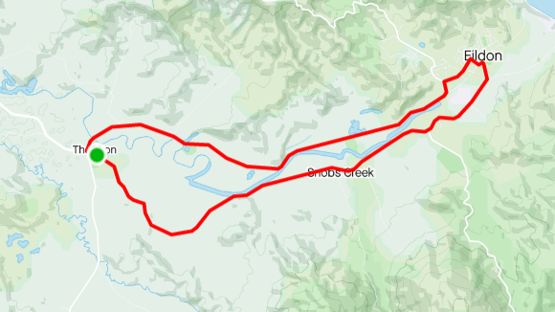
Profile
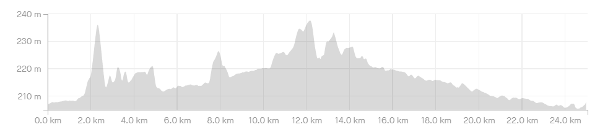

Course Notes
- The registration area is at Thornton Recreation Reserve.
- The race start and rider briefing is at the service road on the Northern side of Goulbourn Valley Hwy (near intersection of Back Eildon Rd).
- The race merges on to Goulbourn Valley Highway and follows the course in an anti-clockwise direction.
- The course proceeds to Eildon on the Goulburn Valley Highway and turns left just after crossing the bridge, this corner will be under the control of a Traffic Controller and as such you should have unimpeded progress through the corner BUT heed the corner marshal.
- Follow the road to the right – Centre Road (do not go straight ahead into the park)
- Left at the next roundabout – High Street.
- Left at the next roundabout – Back Eildon Road.
- The finish is on Back Eildon Road about 2k out of Thornton.
- Bunch passing manoeuvres are neutral; you are not to attack your bunch when passing another grade or when being passed by another grade.
- Bunch passing is not allowed in the corners, if you are approaching a slower bunch leading into a corner; back off, let them take the corner, pass them on the next straight.
- You are to keep left of the centre of the road at all times, numbers will be taken, riders will be disqualified.
- The race is neutral to the first crossing of the finish line (Back Eildon Road); nobody is to ramp things up until they are sure everybody is present. [neutral zone N/A for ITT / TTT]

