Seymour
Address | Google Map Link (Registration)  Google Map Link (Race Start)
Distance (1 lap) | 28.65 Km
Elevation Gain (1 lap) | 119 metres
Distance # Laps | 2 laps
Parking | - Parking in Seymour
Toilets | - Toilets in Seymour
Map
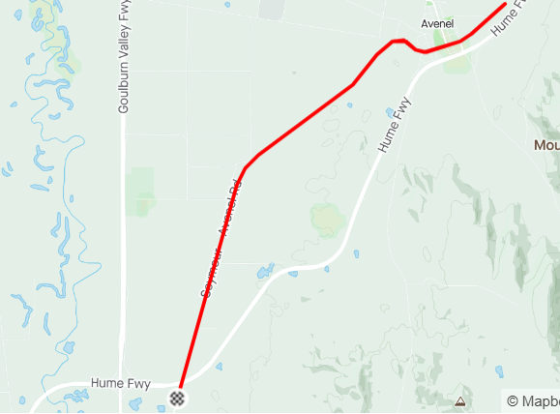
Profile
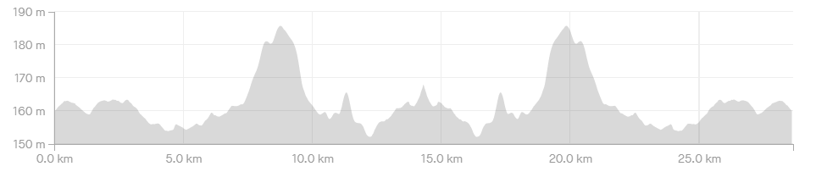

Course Notes
- Registrations are in Manners St, Seymour. Across the road from the Royal Hotel
Rider Briefing/race start is 3.5k along Seymour-Avenel Rd.
- Registration is nearly six kilometres from the race start, you will need to allow sufficient time to get from one to the other.
- Post-race presentations are held in the Royal Hotel, either the beer garden or their back room.
- Race circuit is straight up Seymour-Avenel Rd, through Avenel on Mitchel St, out of Avenel on Spencers Rd, u-turn before the bitumen runs out and back to the start. Repeat!
- It is your RESPONSIBILITY to ensure it is safe to cross to the right-hand side of the road before you do so. A vehicle may have passed the traffic controller before you are seen, and the traffic controller has had the opportunity to stop the traffic. A driver may ignore the traffic controller’s instructions.
- Bunch passing manoeuvres are neutral; you are not to attack your bunch when passing another grade or when being passed by another grade.
- Bunch passing is not allowed in the corners, if you are approaching a slower bunch leading into a corner; back off, let them take the corner, pass them on the next straight.
- You are to keep left of the centre of the road at all times, numbers will be taken, riders will be disqualified.

