Garfield
Address | Google Map Link
Distance (1 lap) | 22.35 Km
Elevation Gain (1 lap) | 44 metres
Distance # Laps | 3 laps
Direction | Anti Clockwise
Parking | - Parking is available at the start
Toilets | - Toilets are available at the start
Map
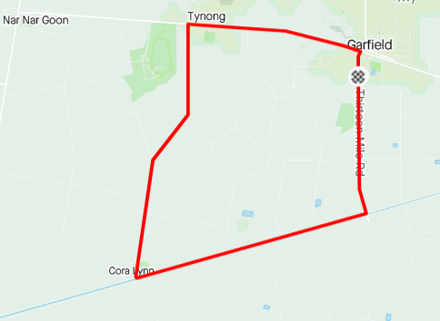
Profile
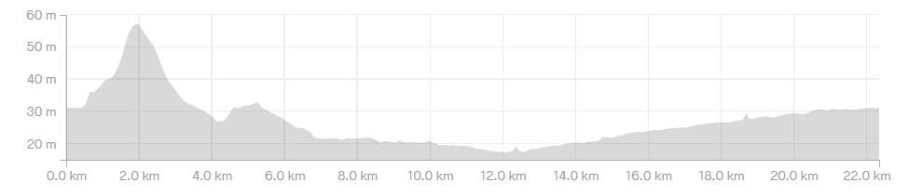

Course Notes
- Registration in Beswick Street, Garfield at the rear of the pub, approximately 50M from the intersection of Thirteen Mile Road.
- The race turns left as outlined below. These corners will be under the control of a Traffic Controller and as such you should have unimpeded egress through the corner BUT heed the corner marshal and stay on the left hand side of both roads.
  - The race proceeds from the start along the NarNarGoon-Longwarry Rd.
  - Left at Nine Mile Rd (4.5 km)
  - Left at Bunyip River Rd (6.5 km)
  - Left at Thirteen Mile Rd (6.5 km)
  - Left at NarNarGoon-Longwarry Rd (4.5 km)
- The road will be controlled for the finish, there is approximately a 1k straight line sprint to the finish, riders are to keep left for the bulk of that distance then are welcome to use both sides of the road for the sprint BUT riders are not to cross to the righthand side of the road until they are CERTAIN that there is no traffic between them and the finish line
- Bunch passing manoeuvres are neutral; you are not to attack your bunch when passing another grade or when being passed by another grade.
- Bunch passing is not allowed in the corners, if you are approaching a slower bunch leading into a corner; back off, let them take the corner, pass them on the next straight.
- You are to keep left of the centre of the road at all times, numbers will be taken, riders will be disqualified.

