METEC

Address | Google Map Link
Distance (1 lap) | 1.21 Km
Elevation Gain (1 lap) | 3 metres
Direction:  Map | Anti Clockwise
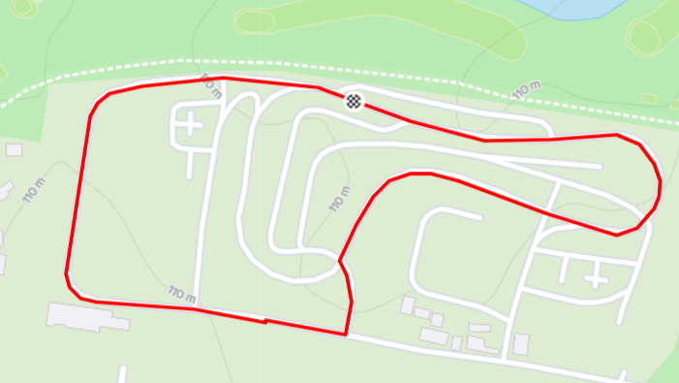
Profile
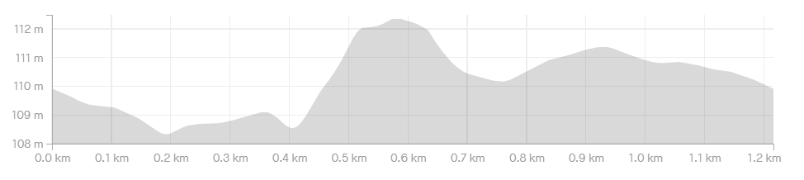

Casey Fields

Address | Google Map Link
Distance (1 lap) | 2.25 Km
Elevation Gain (1 lap) | 7 metres
Direction  Map | Anti Clockwise
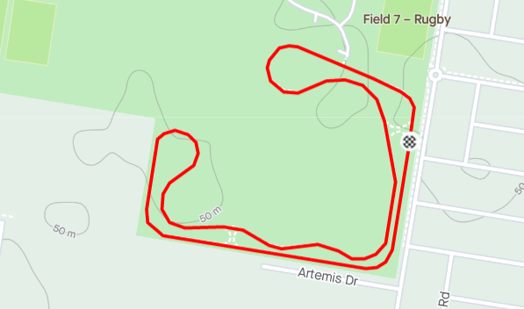
Profile
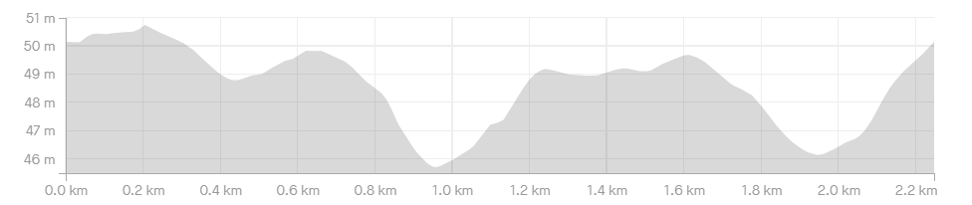

Dunlop Road

Address | Google Map Link
Distance (1 lap) | 1.40 Km
Elevation Gain (1 lap) | 5 metres
Direction  Map | Anti Clockwise
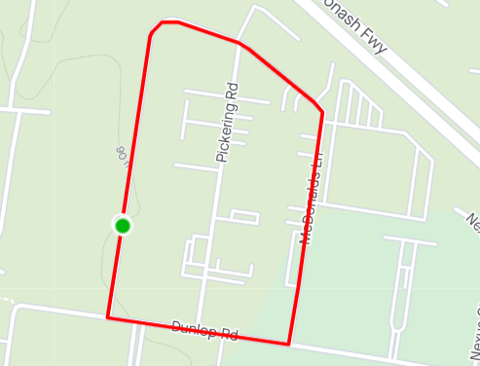
Profile
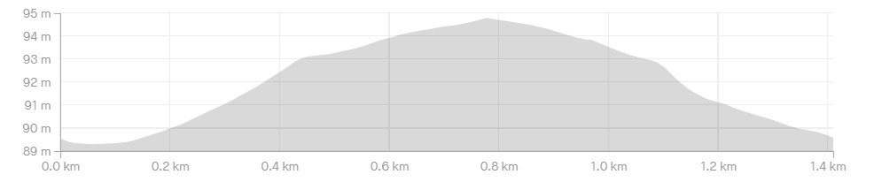

The Teardrop

Address | Google Map Link
Distance (1 lap) | 0.98 Km
Elevation Gain (1 lap) | 28 metres
Direction  Map | Anti Clockwise
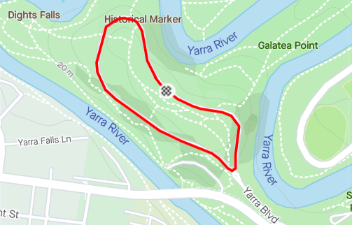
Profile
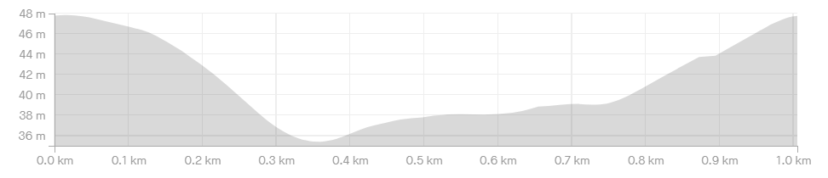

Bazalgette Crescent

Address | Google Map Link
Distance (1 lap) | 1.59 Km
Elevation Gain (1 lap) | 0 metres
Direction  Map | Anti Clockwise
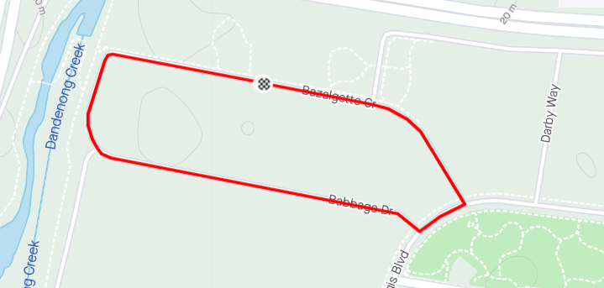
Profile
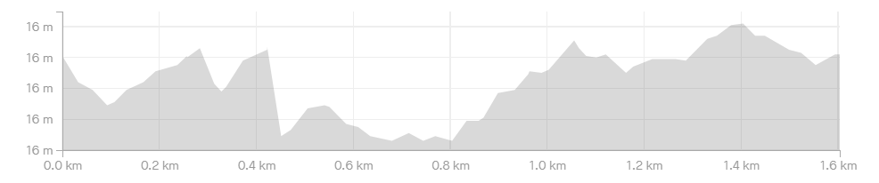

Rocco Drive

Address | Google Map Link
Distance (1 lap) | 0.99 Km
Elevation Gain (1 lap) | 14 metres
Direction  Map | Anti Clockwise
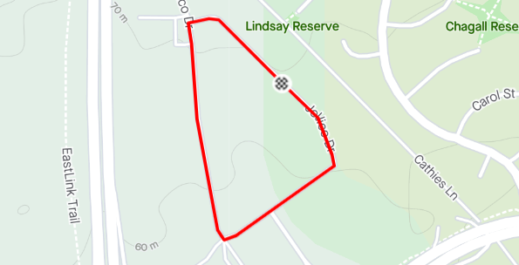
Profile
