Jindivick

Melways Ref:

Getting there
- From the eastern suburbs take the M1 (Princes Hiway) and head east
- Turn left at Longwarry onto Sand Rd heading to Labertouche, then right onto Princes Way then left on to Labertouche Road
- From there just follow you nose, soon Labertouche Road turns into Jacksons Track and then you are there
– on the right 100m past Jindivick General Store
Registration and parking at reserve, toilets available

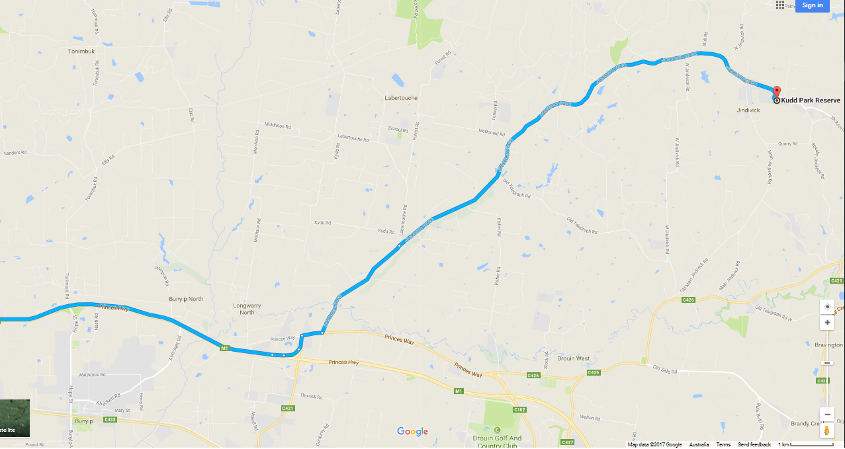

Circuit
- Registration at Kydd Park Reserve
- Rider Briefing/race start is at registration
- Back along Jacksons Track
- Left onto West Jindivick Rd
- Old Telegraph Road
- Left onto Old Main Jindivick Rd.
- Through the finish and left onto Jacksons Track
- Repeat – twice for A & B (3 laps, 60k), once for C & D (2 laps), ?? for E & F grades (TBD)

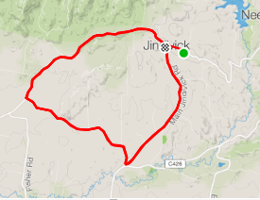

The profile - to follow.

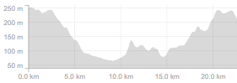
The above profile starts at the start in Kydd reserve before joining the circuit, there is overlap, the first ‘up’ is the same section of the course as the last ‘up’.
.

