Yarra Glen

Melways Ref: 266 J11

Getting there:

- From Eltham take Main Rd to Kangaroo Ground After Kangaroo Ground turn right onto Eltham – Yarra Glen Rd After the descent and crossing the aqueduct turn right onto Glenview Rd
- From Yarra Glen – follow your nose, or the cars with bikes on their rooves.

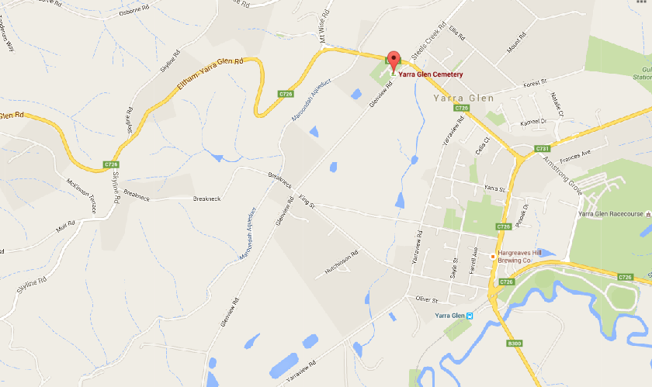

Pre-amble:
- Registrations are in the cemetery car park on Glenview Road.
- No $50 notes, no silver.
- Toilets should be available at the cemetery
Extra toilets are available in Yarra Glen (5 min. ride), suggest you drop in there on your way
- Parking is available in the carpark, extra parking on roadside.
- Please do not park such that your vehicle obstructs the bridal path along the back of the parking area.
- If parking on the side of the road pull well off the road so as not to impede passing traffic or endanger cyclists.

Race circuit:
- Rider briefing/race start is at the cemetery
- The race proceeds from the start to King Street where it makes a left to enter the circuit proper.
- The race descends King Street and turns right into Yarraview Road,
this corner will be under the control of a Traffic Controller and as such you should have unimpeded egress through the corner BUT heed the corner marshal and stay on the left hand side of both roads.
- The second turn, from Yarraview into Glenview is a very tight turn, there is no traffic control, you are to obey the corner marshal.
This is (usually) a quiet corner, and given the tightness we waive the keep left rule for this turn BUT be aware of the possibility of approaching traffic – visibility is good – look ahead, watch the corner marshal.
DO NOT undertake any rider on this (or any other) corner.
- The third, from Glenview into King Street has no traffic control; you are to obey the corner marshal. This is a normal 90 degree turn, there will be cones marking the centre line, you are NOT to ‘wilfully’ cut the corner, numbers will be taken, riders will be disqualified.
- The above equates to a 5k lap, A & B grades will complete 12 laps (~60k), C & D grades 9 laps (~45k), E & F grades 6 laps (~30k)
- The finish is on Yarraview Road.
- The road will be controlled for the finish, there is approximately a 1.2k straight line sprint to the finish, riders are to keep left for the bulk of that distance then are welcome to use both sides of the road for the sprint BUT riders are not to cross to the right hand side of the road until they are CERTAIN that there is no traffic between them and the finish line.
It is your RESPONSIBILITY to ensure it is safe to cross to the right hand side of the road before you do so.
A vehicle may have passed the traffic controller before you are seen and the TC has had the opportunity to stop the traffic.
A driver may ignore the traffic controller’s instructions.

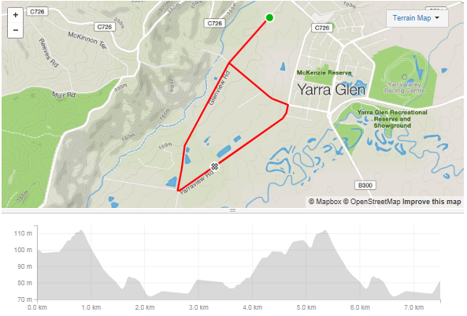

The elevation shown includes the neutral run from start to race circuit (0m - 800m) and the run from top of King Street to the finish (from 5.4k to finish). For actual lap profile take from highest point to highest point (0.8k – 5.4k)

Course Specific Notes:
- The race is neutral to the first crossing of the finish line (Yarraview Road), nobody is to ramp things up until they are sure everybody is present.
- Bunch passing manoeuvres are neutral; you are not to attack your bunch when passing another grade or when being passed by another grade.
- Bunch passing is not allowed in the corners, if you are approaching a slower bunch leading into a corner; back off, let them take the corner, pass them on the next straight.
- You are to keep left of the centre of the road at all times – especially on King Street where speeds will get quite high, numbers will be taken, riders will be disqualified.
- You are to mind your language.

.

