Arthurs Creek

Melways Ref. 510 N12

Getting there:
- from Plenty Rd (or Yan Yean) Rd turn right onto Arthurs Creek Rd, pass through Arthurs Creek to the reserve at the bottom of the hill
- from Hurstbridge, follow Hurstbridge-Arthurs Creek Rd

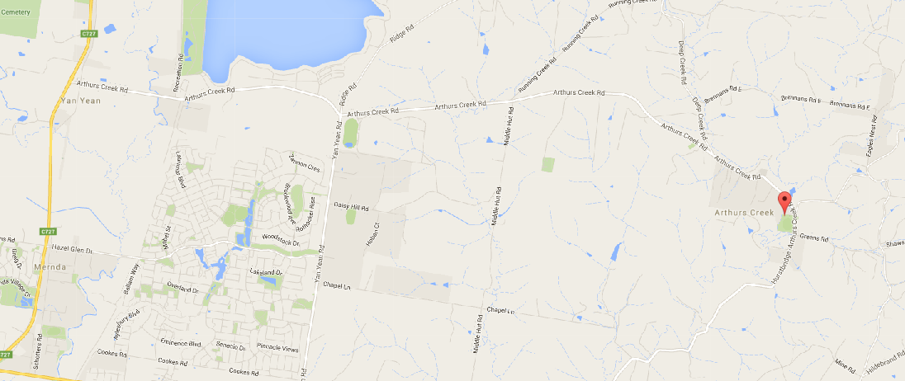

Pre-amble:
- Registrations are at the reserve at the bottom of the hill - across from the CFA.
- No $50 notes, no silver.
- Toilets are available at the reserve
- Parking is available at the reserve, extra parking on roadside and up at the Primary School.
- DO NOT park on the CFA hardtop,
- DO NOT park such that your vehicle impedes access to the CFA hard top.
- If parking on the side of the road pull well off the road so as not to impede passing traffic or endanger cyclists.

Race circuit:
- Rider briefing/race start is on the CFA hard Top
- The race proceeds from the start to Greens Road where it crosses the finish line (the only time you will see it before you finish)
- The race turns left at the end of Greens Road and proceeds to Strathewen and beyond
- Just before the end of the bitumen the race does a u-turn and returns back the way it came to Greens Road
- The race continues past Greens Road – 50m, where it does another u-turn (to complete the lap) and heads back out to Strathewen again
- A & B grades will complete 4 of these out and back loops (~64k), C & D grade 3 (~48k), E & F grades 2 laps (~32k)
- On the last lap the race does exactly the same thing as previous laps, it proceeds 50m past the end of Greens Road, completes a u-turn then turns left into Greens Road toward the finish.
At no time does the race turn right into Greens Road
- The road will be controlled for the finish, there is approximately a 200m straight line sprint to the finish, riders are welcome to use both sides of the road for the sprint BUT riders are not to cross to the right hand side of the road until they are CERTAIN that there is no traffic between them and the finish line.
It is your RESPONSIBILITY to ensure it is safe to cross to the right hand side of the road before you do so.
We (the officials) will not see you till you are around that last bend, a vehicle may have passed the traffic controller before you are seen and the TC has had the opportunity to stop the traffic.
A driver may ignore the traffic controller’s instructions.

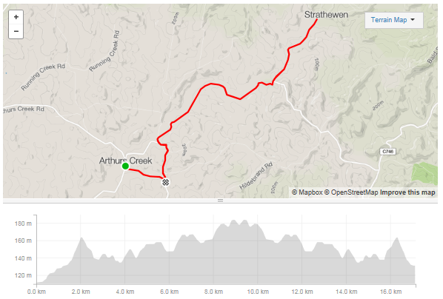

The elevation shown is for a single lap, it does not include Greens Road which is essentially flat (slight downhill run)

Circuit Specific Notes:
- The race is neutral on the first lap to the bottom of the first descent (Nankervis Rd) – about 2k in; the lead rider is not to ramp things up after the descent until they are sure everybody is in contact.
- Turns are NEUTRAL, all turns are neutral.
This means you are not to attack your bunch leading into the turn (approx. 200m), and you are definitely not to attack your bunch out of the turn – you must wait until the bunch has reformed before you resume racing.
It is in the leader’s interest to not ride off but wait, the slower you leave the turn the quicker the bunch will reform and the sooner you can resume racing.
If you have a gap on the bunch (~25+m) you are not considered to be a part of the bunch and you are not obliged to wait.
Please use common sense in making this judgement - we are doing this for enjoyment not for sheep stations.
- The last u-turn (before turning left in to Greens Road) IS NEUTRAL.
Unfortunately, due to permit requirements, we are not permitted to turn right into Greens Road and as such must go past, complete a u-turn, and return to turn left into Greens Road.
This u-turn is NEUTRAL, as tempting as it may be to hit the gas and leave others behind don’t do it
.

